MONDAY 2 FEBRUARY: SCHOOL CLOSED ON TALEBAN ORDERS
I am upset because the schools are still closed here in Swat.
Our school was supposed to open today. On waking up I realised the school was still closed and that was very upsetting. In the past we used to enjoy ourselves on school closure. But this is not the case this time because I am afraid that the school may not reopen at all on the orders of the Taleban.
My father told me that following the closure of private girls' schools, private schools for boys had decided not to open until 8 February. In this regard notices have appeared outside the schools saying that they will reopen on 9 February. My father said that because no such notices have been displayed outside girls' schools, that meant they would not be re-opening.
SATURDAY 31 JANUARY: WHO WILL AVENGE THOSE KILLED?
On our way back to Peshawar from Bannu I received a call from myfriend.
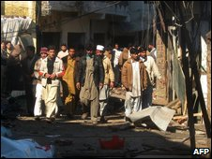
Swat has been hard-hit by Islamic militancy
She was very scared and told me that the situation in Swat was getting worse and I should not come back. She told me that the military operation has intensified and 37 people have been killed only today in the shelling.
We arrived in Peshawar in the evening and were very tired. I switched on the TV and there was a report on Swat. The channel was showing empty-handed people migrating on foot from Swat.
I switched the channel and a woman was saying "we will avenge the murder of Benazir Bhutto". I asked my father who would avenge the deaths of hundreds of people of Swat.
SATURDAY 24 JANUARY: 'MAKING A GRAVE'
The only good thing that has come out of the war in Swat is that our father has taken us away from Mingora (the largest city in the Swat valley) to many other cities. We arrived in Peshawar from Islamabad yesterday. In Peshawar we had tea at one of our relative's houses before travelling to Bannu.
My five-year-old brother was playing on the lawn. When my father asked him what he was playing, he replied 'I am making a grave'.
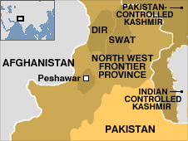
Later we went to a bus stand to travel to Bannu. The wagon was old and the driver was using his horn excessively. On our way the vehicle hit a pot-hole - and at the same time the horn started blowing - waking up my 10-year-old brother.
He was very scared and asked our mother: 'Was it a bomb blast?'
On arrival in Bannu, we found my father's friend waiting for us. He is also a Pashtun but his family spoke a Bannu dialect so we could not understand him clearly.
We went to the bazaar and then to the park. Here women have to wear a veil - called a shuttle veil - whenever they leave their homes. My mother also wore one but I refused to wear one on the grounds that I found it difficult to walk with it on.
Compared with Swat, there is relative peace in Bannu. Our hosts told us that there was a Taleban presence was in the area but there was not as much unrest as in Swat. They said that the Taleban had threatened to close down the schools, but they were still open.

