WEDNESDAY 28 JANUARY: TEARS IN THE EYES OF MY PARENTS
My father fulfilled his promise and we reached Islamabad yesterday. On our way from Swat I was very scared because we had heard that the Taleban conduct searches. But nothing of the sorthappened to us. It was instead the army who conducted the search. The moment we left Swat our fears also subsided.

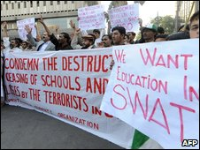
Many are opposed to the militants' policy of closing girls' schools
We are staying with our father'sfriend in Islamabad. It is my first visit to the city. It's beautiful with nice bungalows and wide roads. But as compared to my Swat city it lacks natural beauty. Father took us to Lok Virsa museum and I learnt a lot. We also have such a museum in Swat but I don't know if it will remain undamaged from the fighting.
My father bought popcorn from an old man outside Lok Virsa. When the vendor spoke to us in Pashtu my father asked him if he was from Islamabad. The old man replied: "Do you think Islamabad can ever belong to Pashtuns?"
He said that he hailed from Momand Agency, but because of an ongoing military operation was forced to leave his abode and head for the city. At that moment I saw tears in my parents' eyes.
MONDAY 26 JANUARY: HELICOPTER TOFFEES
I woke to the roar of heavy artillery fire early in the morning. Earlier we were afraid of the noise of helicopters and now the artillery. I remember the first time when helicopters flew over our house on the start of an operation. We got so scared that we hid.
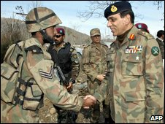
The army is accused of not doing enough to protect schools
All the children in my neighbourhood were also very scared.
One day toffees were thrown from the helicopters and this continued for some time. Now whenever we hear the choppers flying we run out and wait for the toffees but it does not happen anymore. A while back my father gave us the good news that he was taking all of us to Islamabad tomorrow. We are very happy.
SATURDAY 24 JANUARY: NO NAMES ON THE HONOURS BOARD
Our annual exams are due after the vacations but this will only be possible if the Taleban allow girls to go to school. We were told to prepare certain chapters for the exam but I do not feel like studying.
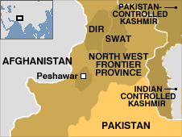
As from yesterday the army has taken control of the educational institutions for protection. It seems that it is only when dozens of schools have been destroyed and hundreds others closed down that the army thinks about protecting them. Had they conducted their operations here properly, this situation would not have arisen.
Muslim Khan (a Swat Taleban spokesman) has said that those schools housing the army would be attacked. We will be more afraid of having the army in our schools than ever. There is a board in our school which is called the Honours Board. The name of the girl achieving the highest marks in annual exams is put on this board. It seems that no names will be put on it this year.

