THURSDAY 22 JANUARY : VERY DANGEROUS SITUATION
I am quite bored sitting at home following the closures of schools.
Some of my friends have left Swat because the situation here is very dangerous. I do not leave home. At night Maulana Shah Dauran (the Taleban cleric who announced the ban on girls attending school) once again warned females not to leave home.
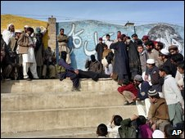
The Taleban routinely carry out public floggings in Swat
He also warned that they would blow up those schools which are used by the security forces as security posts.
Father told us that security forces have arrived at the boys' and girls' school in Haji Baba area. May God keep them safe. Maulana Shah Dauran also said in his speech on FM radio that three 'thieves' will be lashed tomorrow and whoever wants to see can come and watch.
I am surprised that when we have suffered so much, why people still go and watch such things? Why also doesn't the army stop them from carrying out such acts? I have seen wherever the army is there is usually a Taleban member nearby, but where there is a Taleban member the army will always not go.
MONDAY 19 JANUARY: ARMY IN THEIR BUNKERS
Five more schools have been destroyed, one of them was near my house. I am quite surprised, because these schools were closed so why did they also need to be destroyed? No one has gone to school following the deadline given by the Taleban.
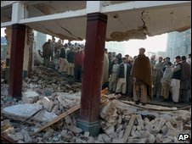
The authorities are accused of doing little to protect schools
Today I went to my friend's house and she told me that a few days back someone killed Maulana Shah Dauran's uncle; she said that it may be that the Taleban destroyed the schools in anger at this.
She also said that no one has made the Taleban suffer but when they are hurt they take it out on our schools. But the army is not doing anything about it. They are sitting in their bunkers on top of the hills. They slaughter goats and eat with pleasure.
FRIDAY 18 JANUARY: NO POLICE IN SIGHT
My father told us that the government would protect our schools. The prime minister has also raised this issue. I was quite happy initially, but now I know but this will not solve our problem. Here in Swat we hear everyday that so many soldiers were killed and so many were kidnapped at such and such place. But the police are nowhere to be seen.
Our parents are also very scared. They told us they would not send us to school until or unless the Taleban themselves announce on the FM channel that girls can go to school. The army is also responsible for the disruption in our education.
Today a boy from our locality went to school and he was told by the principal to go back home because a curfew was to be imposed soon. But when he reached home he came to know that there was no curfew, instead his school was closed down because the army was to move through the road near his school.

